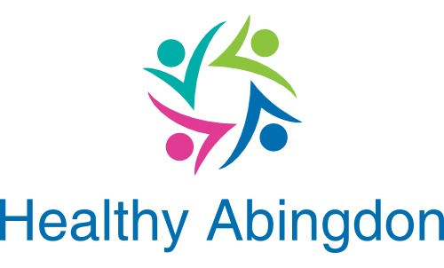
www.healthyabingdon.org.uk

Associate information form
Please complete this form if you want your group to contribute to the Healthy Abingdon Initiative. If you need to know more, contact Dave Butterworth on 01235 525955 or by email at HealthyAbingdon@aol.com. Use additional pages where required although the boxes should grow as you type in more.

Your information will be used to create a web page on our web site. You can find example web pages by going to www.healthyabingdon.org.uk/associates.htm .

Please note
- Healthy Abingdon Associates will normally be charitable or non-profit organisations. If you do not fit into this category, please contact us first to discuss before completing this form.
- The trustees of Healthy Abingdon reserve the right to refuse to accept someone as a Healthy Abingdon Associate. Reasons will be given for any refusal.
- You will be given access to check you web page before it goes live.

Name of group |  | Web site address
Address (if you have central mailing address)

Contact person
 | Name/role | Telephone | Email
As it will appear on web site
For contact from us if different (not to appear on the web site)

Activity
Please give a brief description of what you do

When/where/how often do you meet?

What kind of people do you aim to help?
Who are you aiming your activities at? Is it adults, children, elderly, those with physical or mental problems or carers?

What extra safeguards do you have if you deal with children or vulnerable adults?

Additional information if you provide treatments or therapeutic services
What training and qualifications do your therapists have?

Please add any further information if not covered by the above.

You are also welcome to send a picture and your logo (jpeg or png file) to include on your web page.

Please return completed for to
Dave at HealthyAbingdon@aol.com, Or send by post to Healthy Abingdon, 29 Clevelands, Abingdon, Oxon, OX14 2EQ.

